ST. PANCRAS INTERNATIONAL CAROLLING FOR CAUSES 2026

Throughout December, St. Pancras International offers charities and community groups spaces in the station to perform as a part of the annual Christmas carol programme. By performing in the station, charities can get great exposure to audiences in a fun and experiential way and can raise money for their good causes.

The Christmas Carol programme is supported by London St. Pancras Highspeed's marketing campaign over the Christmas period, including professional photography and social media support to over 160k followers.

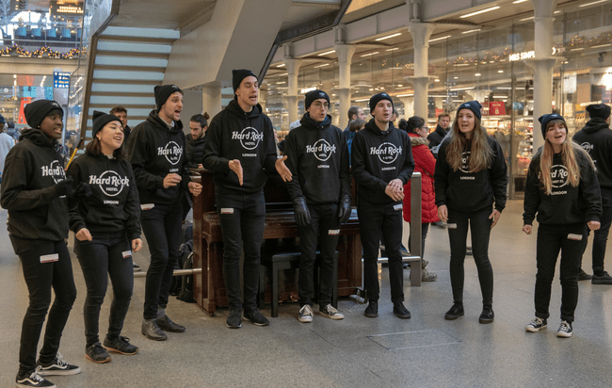
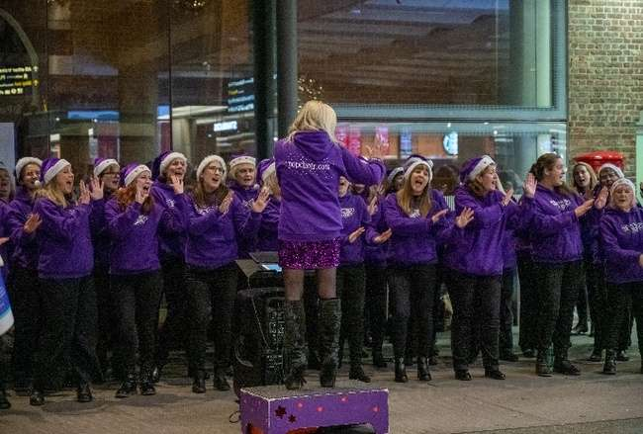

If you would like to apply to perform at the station, we require all choirs and groups to meet with the following criteria:

- For maximum impact, we want choirs to stand out from the crowds by wearing their charity’s branded clothing or matching colours uniform/clothing or even props (examples shown in the pictures above).

- With it being an increasingly cashless society that we live in, we encourage charities that use contactless technology to collect funds. In previous years, the charities that provided the facility for contactless donations made more money than those using just bucket collections. The station has free Wi-Fi that can be used for this.

To apply for a performance slot at the station, there is a three-part application which must be completed and signed. All documents must be submitted in full, accompanied by your proof of Public Liability Insurance.

- Part 1 – Send details of charity, group size and requested date(s) to London St. Pancras Highspeed via specialevents@stpancras-highspeed.com for approval. Subject line: C4C [Choir/Charity name]
- Part 2 – Please review our Terms and Conditions, available here: Terms & Conditions Terms & Conditions - London St. Pancras Highspeed. Pease write your signature to confirm you accept and acknowledge our T&Cs.
- Part 3 - Complete Risk Assessment & Method Statement (RAMS) Agreement which London St. Pancras Highspeed will be submitted on your behalf to Network Rail High Speed for approval.

We require the RAMS at least two weeks ahead of performance to allow for sign off period. Please submit the documents completed in full and accompanying proof of PLI to: specialevents@stpancras-highspeed.com

We will respond as soon as possible to confirm your application and agreed dates and times.

Part 1: Application Form - Carolling For Causes 2026

TO BE COMPLETED IN BLOCK CAPITAL LETTERS
Applicant Name
Applicant Company
Which charity are you raising money for?
(if different to applicant)
Charity Number
Charity Instagram handle
Applicant Address | Postcode:
Applicant Email
Applicant Mobile No.
Public Liability Insurance for Performance  MUST PROVIDE COPY OF CERTFICATE | Start Date |  | End Date
Lead Contact Name
(for on the day)
Lead Contact Email
(for on the day)
Lead Contact No.
(for on the day)
How many people will attend to sing?
Please provide full details about the performance
Do you require use of a piano? (max 10 people)
Preferred Performance Date between 1st – 23rd December 2025. Slot times are available between 5pm and 9pm.

No more than three slots per group.

Sites, dates and times will be allocated to you by London St. Pancras Highspeed once full details about your proposed performance have been reviewed. Places will be allocated on a first come first serve basis for fully completed applications, and we will contact you with alternative details should your preferred slot be filled.

PART 2: TERMS & CONDITIONS

Please review our Terms and Conditions on our website, available here: Terms & Conditions Terms & Conditions - London St. Pancras Highspeed

By signing the below, you acknowledge and accept our Terms and Conditions.

Name
Choir/Company

Date

Signature

PART 3
Risk Assessment & Method Statement (RAMS) for Music Performances at Network Rail (High Speed) Stations (including St. Pancras International Station)
All risks associated with your event shall need to be assessed, and the necessary controls and mitigations advised to ensure the safety of your personnel, station staff/contractors and our passengers/customers. Risk assessments shall need to be suitable and sufficient to meet the requirements of the Management of Health and Safety at Work Regulations 1999.

These Risks listed are correct for the activity that we agree to allow you to undertake, if you have your own risk assessment, please supply as a separate document. For further guidance on risk assessments, please refer to the HSE website (www.hse.gov.uk).

What are the hazards? | Who could be harmed and how? | What are you going to do to reduce the risks? | What further actions are required? | Action to be taken by whom (name)? | Action to be taken by when (date)?
Complaints about music being played | People walking through the station, TOCS and retailers | Sound levels will be monitored by Network rail | Music kept under 85 decibels
Portable Wireless Speaker being used.  Sound from speakers disturbing station announcements | Injury to choir,  station passengers, irritations or time lost due to announcement interference | System to be placed well out of reach of walkways.  Ensure speaker volume is maintained below 85 decibels | Music kept under 85 decibels
Crowding around performances / photography area | People walking through the station and viewing the performance / waiting or observing, crushing and panic | Passenger flow directed by CSAs and stewards from Network rail where appropriate | Tensa barriers to be used to keep performers separated
Positioning of event items / equipment. Obstruction of pedestrian routes | Slips, trips or falls, possible personal legal action. | Trained, competent employees / contractors. | Staff to watch items and make adjustments if needed
Security of event items / equipment - theft | Possible irretrievable loss of items / equipment | Trained, competent employees / contractors. | All items / equipment to be always secured
Unattended equipment and personal belongings causing tripping or security hazards. | Station staff and passengers: time lost through possible security evacuations and bodily injuries caused by trips and falls. | All team members to be fully briefed on station security regulations upon arrival. Competent staff on hand to ensure the no items are left by guests at any time

- You and your party shall always act in a professional manner whilst at the station. NR(HS) has a zero-tolerance policy for all forms of abuse, both physical and verbal and may take legal action should any of our staff, retailers or contractors make a formal complaint.

- Additionally, St. Pancras International Station is a Grade 1 listed building. You shall not be permitted to affix anything (permanent or temporary) to the station fabric without the express permission of London St. Pancras Highspeed, who employs a Historic England advisor – likewise, trestle tables and stands are not permitted at gate line areas due to both heritage and safety considerations. This permission must be obtained, and proof supplied.

By signing this Network Rail (High Speed) Risk Assessment Method Statement, you agree that;
- I hereby confirm, I have read the RAMS and I acknowledge the risks identified.
- I confirm that I, and all the attendees to the site, shall always adhere to the requirements of Part 3.
- I, and all attendees also accept that the event shall be temporarily halted, deferred or cancelled by officials of Network Rail (High Speed) should station operations require it.

Name
Choir/Company

Date

Signature

